Title:Fire Weather Index Predictor
(A Machine Learning model to predict Fire Weather)



Infosys Springboard Virtual Internship Program

Submitted By
Vanshika Yadav

Under the guidance of Mentor Praveen

Project Statement
This project focuses on building a Fire Weather Index (FWI) Predictor that estimates wildfire risk using essential environmental and fire-danger features such as temperature, relative humidity, wind speed, rainfall, FFMC, DMC, DC, ISI, and BUI. The dataset is thoroughly cleaned, pre-processed, and analysed to ensure reliable inputs, followed by visual exploration to understand feature distributions and relationships. Machine learning techniques are then applied to learn how weather conditions influence fire danger levels, enabling accurate prediction of the FWI value. The system also incorporates regional information to study area-wise fire behaviour and improve prediction relevance. Overall, the model aims to support early detection, risk assessment, and informed decision-making for effective wildfire management.

Expected Outcome
• A predictive ML model trained using Ridge Regression to forecast FWI.
• A Flask-based web app where users can input environmental values and get FWI predictions.
• A system that can help forest departments, emergency planners, and climate researchers make data-driven decisions.

Modules to be Implemented
• Data Collection
• Data Exploration (EDA) and Data Preprocessing
• Feature Engineering and Scaling
• Model Training using Ridge Regression
• Evaluation and Optimisation
• Deployment via Flask App
• Presentation and Documentation

System Requirements
Software:
- Python
- Python libraries (pandas, numpy, matplotlib, seaborn etc)
- Flask

Milestone 1(Week 1,2)
- Module 1 (Data Collection)

The dataset was collected by exploring multiple online sources and selecting one that contained the essential environmental features required for FWI prediction, including Temperature, Relative Humidity, Wind Speed, Rain, FFMC, DMC, ISI, and Region. After loading the chosen dataset into a Pandas DataFrame, an initial inspection was carried out to understand its structure and quality. This included checking datatypes, identifying null values, reviewing memory usage, and generating statistical summaries to examine the distribution and range of numerical features. The dataset’s shape and duplicate entries were also analysed to ensure completeness and reliability, providing a solid foundation for further preprocessing and modelling.

Conducted initial inspection to understand feature distributions and data quality.

- Load the dataset
import numpy as np
import pandas as pd
import matplotlib.pyplot as plt
import seaborn as sns
%matplotlib inline

df=pd.read_csv("FWI Dataset.csv", header=1)

- Verify Datatypes

df.info()

<class 'pandas.core.frame.DataFrame'>
RangeIndex: 246 entries, 0 to 245
Data columns (total 14 columns):
# Column Non-Null Count Dtype
--- ------ -------------- -----
0 day 246 non-null object
1 month 245 non-null object
2 year 245 non-null object
3 Temperature 245 non-null object
4 RH 245 non-null object
5 Ws 245 non-null object
6 Rain 245 non-null object
7 FFMC 245 non-null object
8 DMC 245 non-null object
9 DC 245 non-null object
10 ISI 245 non-null object
11 BUI 245 non-null object
12 FWI 245 non-null object
13 Classes 244 non-null object
dtypes: object(14)
memory usage: 27.0+ KB

- Module 2 (Data Exploration (EDA) and Data Preprocessing)

During the preprocessing stage, the dataset was first examined for missing or null values, and appropriate handling techniques were applied to ensure completeness. Outlier detection was then performed using boxplots and statistical thresholds to identify abnormal values that could affect model performance. To better understand feature behaviour, data distributions were visualised through histograms and density plots, while correlation matrices and scatterplots were used to explore relationships between variables. Categorical features, such as Region, were encoded using label encoding to make them suitable for machine learning algorithms. Finally, the cleaned and processed dataset was saved for use in building and evaluating predictive models.

- Handle missing values

df=df.drop(122).reset_index(drop=True)

df.isnull().sum()

day 0
month 0
year 0
Temperature 0
RH 0
Ws 0
Rain 0
FFMC 0
DMC 0
DC 0
ISI 0
BUI 0
FWI 0
Classes 0
region 0
dtype: int64

A missing-value check was performed to identify incomplete records, revealing that only one row contained a null value in the Classes column. This validation helped ensure data completeness and supported appropriate handling before further preprocessing.

- Density Plots and histogram for each feature

Histograms with KDE density curves were generated for all numerical features to visualize their distributions and identify underlying patterns. These plots helped reveal whether features were normally distributed, skewed, or contained extreme values. Variables like Temperature, RH, and Wind Speed showed smoother, more symmetric distributions, while features such as Rain, DMC, ISI, and BUI displayed strong right-skewness. This visual exploration provided valuable insights for understanding variability and preparing the data for modeling.
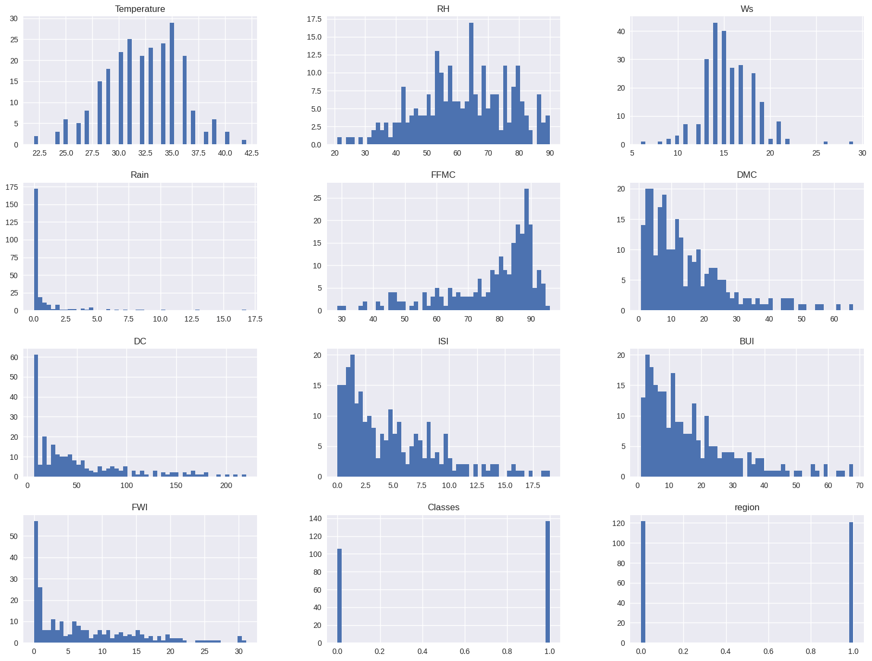
FIG 4: Histogram with KDE curves for features

- Compute the correlation matrix for numerical features

A correlation matrix was generated to explore relationships among numerical features and identify which variables influence each other most strongly. The heatmap revealed that fire danger indices such as BUI, DMC, FFMC, and ISI have high positive correlations with each other and with Temperature, indicating shared patterns in fire behavior. Relative Humidity showed strong negative correlations with several indices, reflecting its inverse effect on fire risk. These insights helped highlight key predictive features for the Fire Weather Index and guided feature selection for modeling.
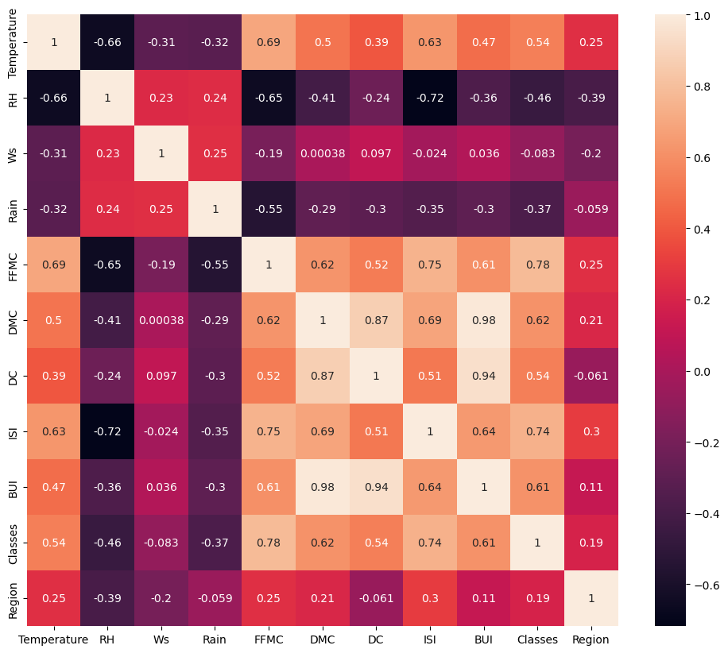

FIG 5: Correlation matrix

Milestone 2(Week 3,4)

- Module 3 (Feature Engineering and Scaling)
In this module, the dataset was prepared for model training by applying feature engineering and scaling techniques. The main aim of this step was to improve data quality and ensure better performance of the machine learning model. First, the important input features were selected based on their relationship with the target variable, Fire Weather Index (FWI). By choosing only the most relevant features, unnecessary columns were removed, which helped in reducing complexity and improving the efficiency of the model. After selecting the features, numerical data was scaled using StandardScaler. Since the dataset contained values in different ranges, scaling was necessary to bring all features to a common scale. This step ensured that each feature contributed equally during model training and prevented bias towards features with larger values. Once scaling was completed, the dataset was divided into input variables (X) and the output variable (y). The data was then split into training and testing sets using the train_test_split method. This allowed the model to be trained on one portion of the data and tested on unseen data for proper evaluation.Finally, the fitted scaler was saved as a .pkl file. Saving the scaler ensures that the same preprocessing steps can be applied to new data during deployment, maintaining consistency between training and real-time predictions.
- Feature Selection
## Independent And dependent features
X=df.drop('FWI',axis=1)
y=df['FWI']

X.head()

Y
0 0.5
1 0.4
2 0.1
3 0.0
4 0.5
...
238 6.5
239 0.0
240 0.2
241 0.7
242 0.5
Name: FWI, Length: 243, dtype: float64

- Standard Scaler Application and train_test_split

#Train Test Split
from sklearn.model_selection import train_test_split
X_train,X_test,y_train,y_test=train_test_split(X,y,test_size=0.25,random_state=42)

X_train.shape,X_test.shape

((182, 11), (61, 11))

## Feature Selection based on correlaltion
X_train.corr()

## Check for multicollinearity
plt.figure(figsize=(12,10))
corr=X_train.corr()
sns.heatmap(corr,annot=True)

<Axes: >
X_train.corr()

def correlation(dataset, threshold):
col_corr = set()
corr_matrix = dataset.corr()
for i in range(len(corr_matrix.columns)):
for j in range(i):
if abs(corr_matrix.iloc[i, j]) > threshold:
colname = corr_matrix.columns[i]
col_corr.add(colname)
return col_corr

## threshold--Domain expertise
corr_features=correlation(X_train,0.85)

corr_features

{'BUI', 'DC'}

## drop features when correlation is more than 0.85
X_train.drop(corr_features,axis=1,inplace=True)
X_test.drop(corr_features,axis=1,inplace=True)
X_train.shape,X_test.shape

((182, 9), (61, 9))

from sklearn.preprocessing import StandardScaler
scaler=StandardScaler()
X_train_scaled=scaler.fit_transform(X_train)
X_test_scaled=scaler.transform(X_test)

X_train_scaled

array([[-0.84284248, 0.78307967, 1.29972026, ..., -0.62963326,
-1.10431526, -0.98907071],
[-0.30175842, 0.64950844, -0.59874754, ..., -0.93058524,
-1.10431526, 1.01105006],
[ 2.13311985, -2.08870172, -0.21905398, ..., 2.7271388 ,
0.90553851, 1.01105006],
...,
[-1.9250106 , 0.9166509 , 0.54033314, ..., -1.06948615,
-1.10431526, -0.98907071],
[ 0.50986767, -0.21870454, 0.16063958, ..., 0.5973248 ,
0.90553851, 1.01105006],
[-0.57230045, 0.98343651, 2.05910739, ..., -0.86113478,
-1.10431526, -0.98907071]], shape=(182, 9))

plt.subplots(figsize=(15, 5))
plt.subplot(1, 2, 1)
sns.boxplot(data=X_train)
plt.title('X_train Before Scaling')
plt.subplot(1, 2, 2)
sns.boxplot(data=X_train_scaled)
plt.title('X_train After Scaling')

Text(0.5, 1.0, 'X_train After Scaling')

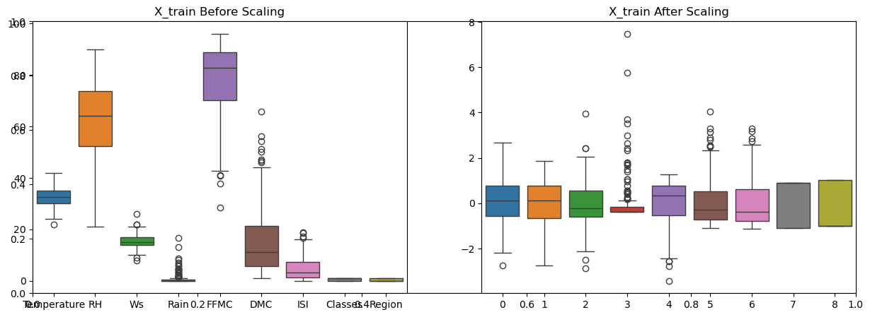
from sklearn.linear_model import LinearRegression
from sklearn.metrics import mean_absolute_error
from sklearn.metrics import r2_score
linreg=LinearRegression()
linreg.fit(X_train_scaled,y_train)
y_pred=linreg.predict(X_test_scaled)
mae=mean_absolute_error(y_test,y_pred)
score=r2_score(y_test,y_pred)
print("Mean absolute error", mae)
print("R2 Score", score)
plt.scatter(y_test,y_pred)

Mean absolute error 0.5468236465249973
R2 Score 0.9847657384266952

<matplotlib.collections.PathCollection at 0x2142366b7a0>

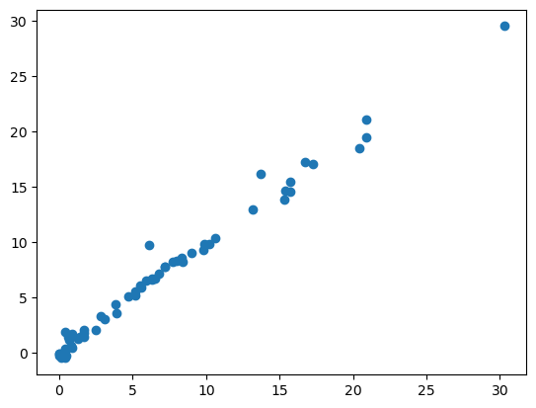

4. Module 4 (Model Training using Ridge Regression)
In this module, a Ridge Regression model was trained to predict the Fire Weather Index (FWI). Ridge Regression was chosen because it performs well when the input features are correlated with each other. It helps reduce overfitting by applying regularization to the model. The model was trained using the scaled training dataset. During this process, the alpha parameter was adjusted to control the balance between model complexity and prediction accuracy. Selecting an appropriate alpha value helped in achieving stable and reliable predictions. After training, the model’s performance was evaluated on both the training and testing datasets. This evaluation confirmed that the model was learning effectively and producing consistent results on unseen data. Once the model showed satisfactory performance, it was saved using the pickle library as ridge.pkl. Saving the trained model allows it to be reused later without retraining. All important steps, parameters, and observations from the training process were documented for future reference and reproducibility.
- Model Training and Model Evaluation
from sklearn.linear_model import Ridge
from sklearn.metrics import mean_absolute_error
from sklearn.metrics import r2_score
ridge=Ridge()
ridge.fit(X_train_scaled,y_train)
y_pred=ridge.predict(X_test_scaled)
mae=mean_absolute_error(y_test,y_pred)
score=r2_score(y_test,y_pred)
print("Mean absolute error", mae)
print("R2 Score", score)
plt.scatter(y_test,y_pred)

Mean absolute error 0.5642305340105692
R2 Score 0.9842993364555513

<matplotlib.collections.PathCollection at 0x21425a9dd30>

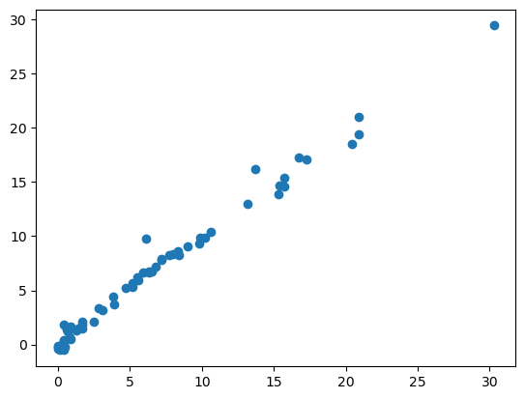

from sklearn.linear_model import RidgeCV
ridgecv=RidgeCV(cv=5)
ridgecv.fit(X_train_scaled,y_train)
y_pred=ridgecv.predict(X_test_scaled)
plt.scatter(y_test,y_pred)
mae=mean_absolute_error(y_test,y_pred)
score=r2_score(y_test,y_pred)
print("Mean absolute error", mae)
print("R2 Score", score)

Mean absolute error 0.5642305340105692
R2 Score 0.9842993364555513

ridgecv.get_params()

{'alpha_per_target': False,
'alphas': (0.1, 1.0, 10.0),
'cv': 5,
'fit_intercept': True,
'gcv_mode': None,
'scoring': None,
'store_cv_results': False}

